Picture Perfect Design Document

* Overview
* Backend
* Language
* Use Case Diagram
* Database
* ER Diagram
* Database Tables
* Authentication

* Frontend/UI
* Language
* Library
* UX Mock Layout
* CI/CD
* Deployment
* Code Repository
* Automation

**Overview:**

Picture Perfect is an online movie ticket booking, review and rating service. The service helps users generate reviews and rating content for movies across the world. One may wish to publish only a rating or a full review of the movie in a language of choice.

**Backend:**

**Language:** Golang

Go is one of the smallest and simplest languages in the world. Go compiles lightning-quick into fast native code. Go has excellent support for concurrency with goroutines and channels. Go is portable. Code compiles into single binary (no need to install dependencies). It also works great on different OS. Tests that are automated using Go can be executed on Windows, Linux, MacOS and each goroutine is 10x cheaper in resources than python thread.

**Use Case Diagram:**

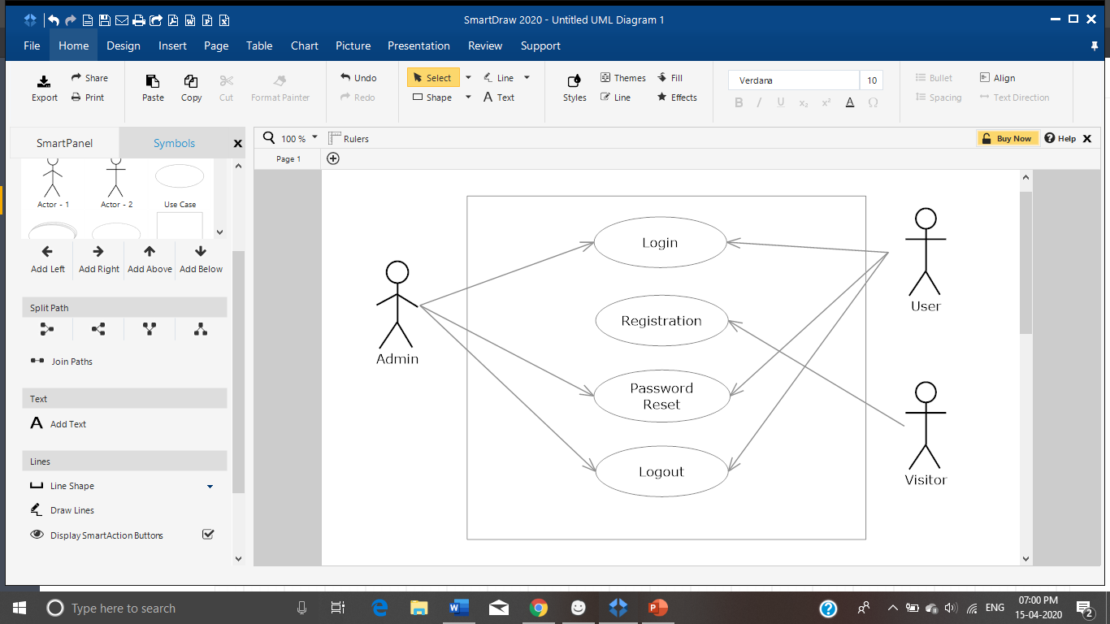

User Authentication

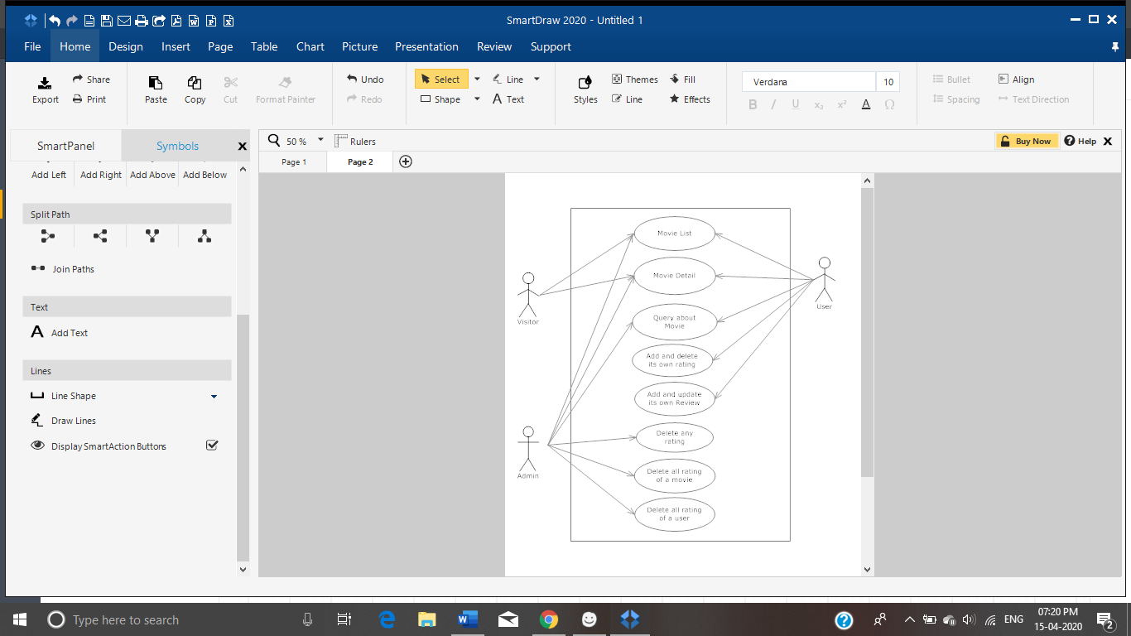

Movie Catalogue

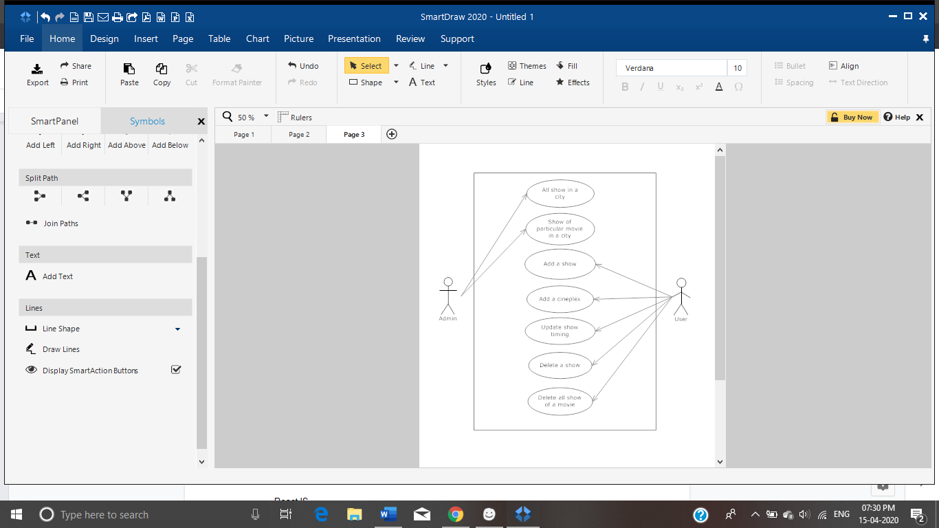

Cineplex shows

**Database:** MySQL

MySQL is the relational database which follows atomicity, consistency, isolation and durability (i.e. ACID properties)

**ER Diagram:**

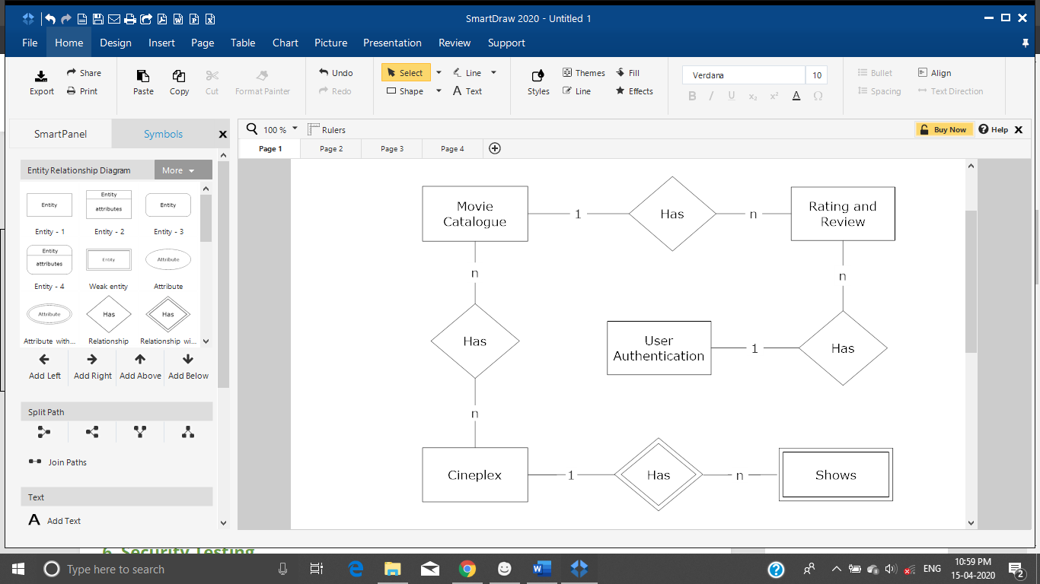

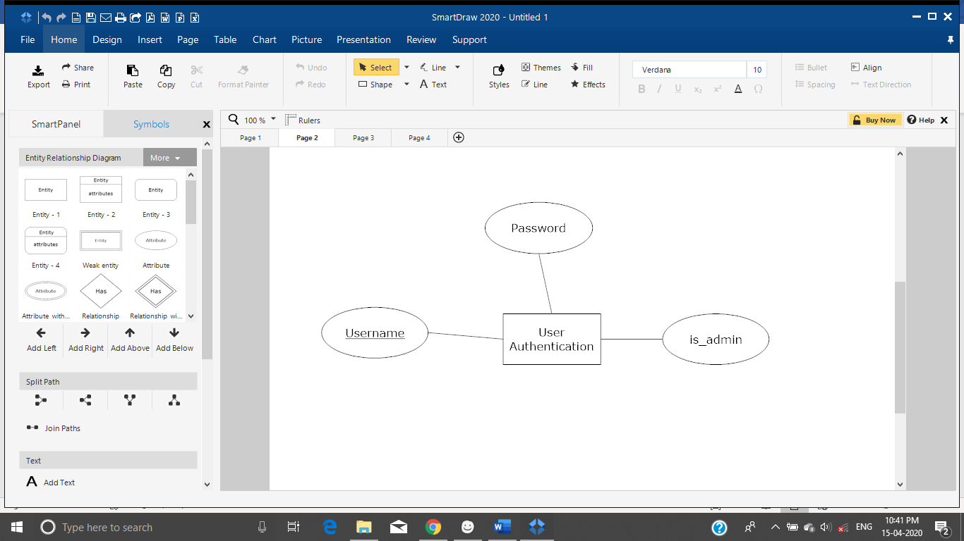

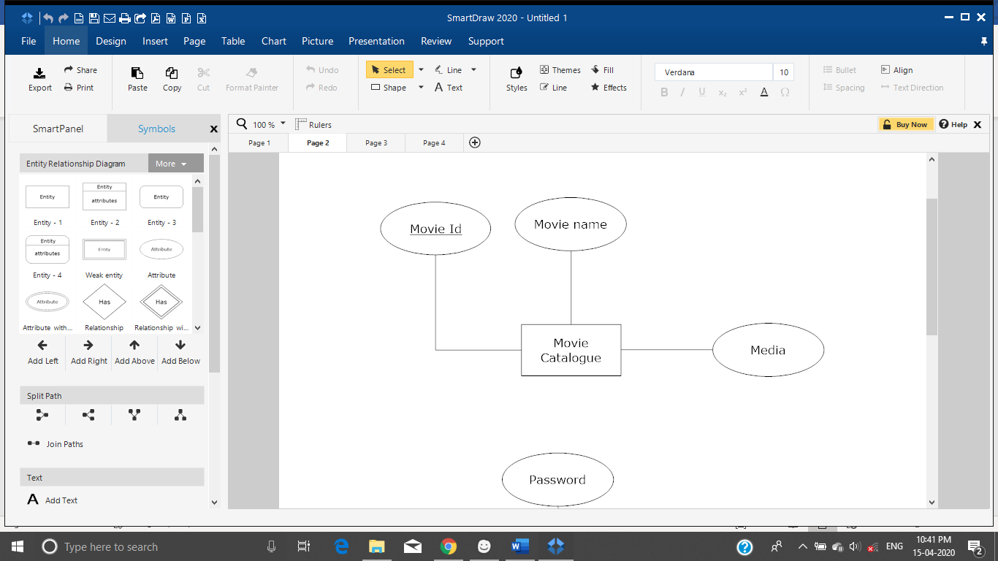

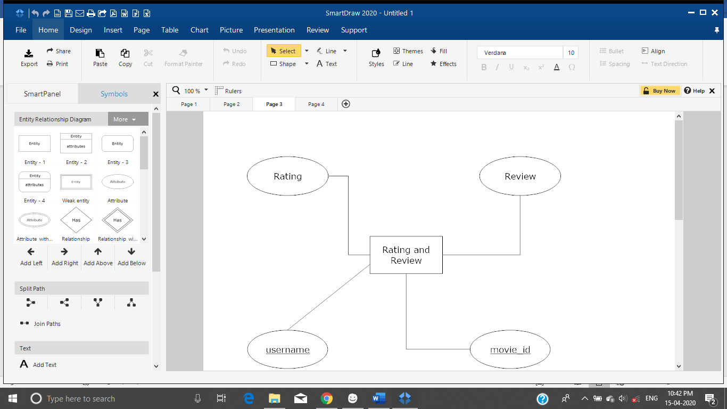

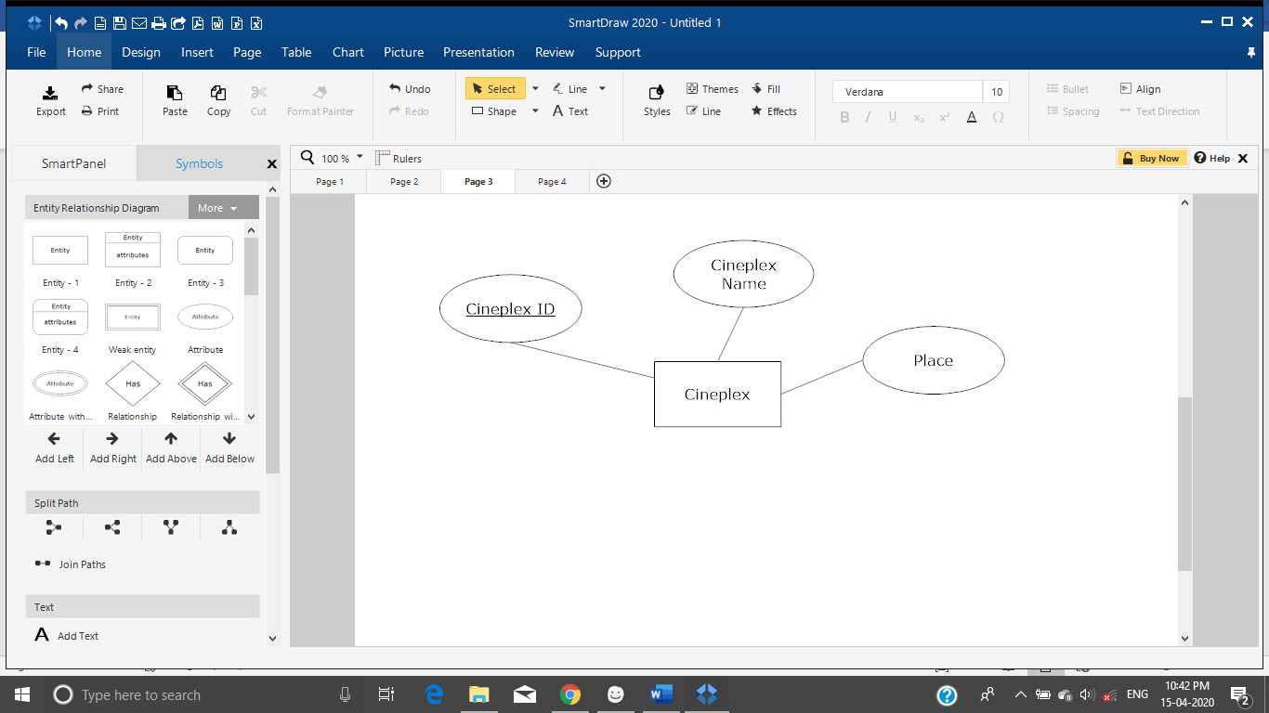

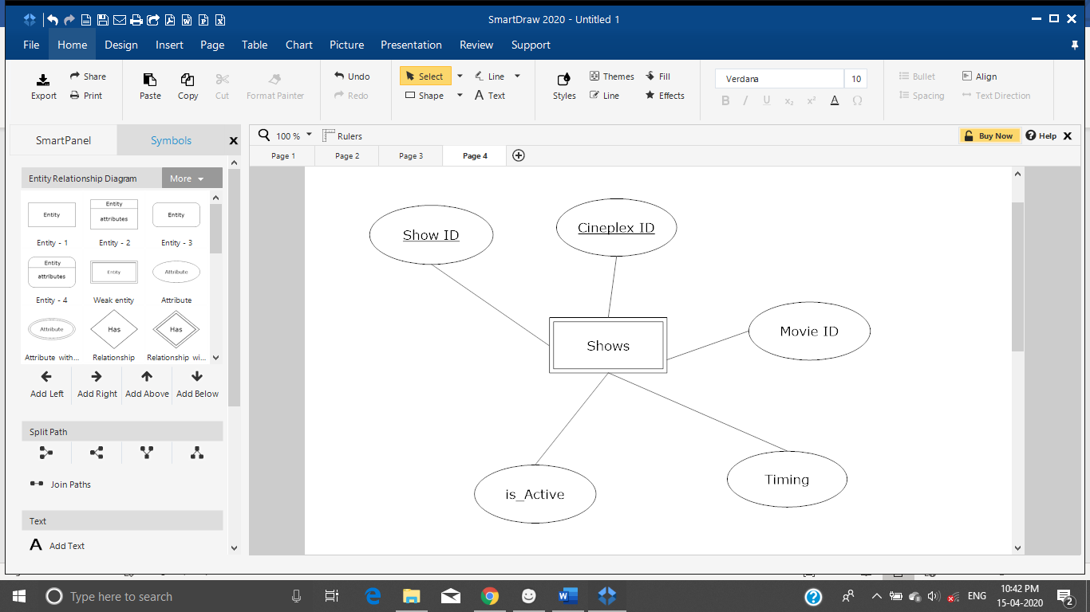

**Database Tables:**

User Authentication:

|  |  |
| --- | --- |
| **Attribute** | **Type** |
| Username | String (Primary Key) |
| Password | String |
| is_admin | Boolean |

Primary Key: (Username)

Movie Catalogue Table:

|  |  |
| --- | --- |
| **Attribute** | **Type** |
| Movie ID | String (Primary Key) |
| Movie Name | String |
| Media Links | Media |

Primary Key: (Movie ID)

Rating and Review Table:

|  |  |
| --- | --- |
| **Attribute** | **Type** |
| Movie ID | String |
| Username | String |
| Rating | Integer |
| Review | String |

Primary Key: (Movie ID, Username)

Cineplex Table:

|  |  |
| --- | --- |
| **Attribute** | **Type** |
| Cineplex ID | String |
| Cineplex Name | String |
| Place | String |

Primary Key: (Cineplex ID)

Movie Shows Table:

|  |  |
| --- | --- |
| **Attribute** | **Type** |
| Cineplex ID | String |
| Movie ID | String |
| Show Timing | Date |
| Is_active | Boolean |

Primary Key: (Cineplex ID, Movie ID)

Session Table:

|  |  |
| --- | --- |
| **Attribute** | **Type** |
| Session UUID | String |
| Username | String |

Primary Key: (Session UUID)

**Authentication:** JWT API

JSON Web Token (JWT) is an internet standard for creating JSON-based access tokens that assert some number of claims. The tokens are signed either using a private secret or a public/private key. For example, a server could generate a token that has the claim "logged in as admin" and provide that to a client.

**Frontend/UI:**

**Language:** HTML, CSS, JavaScript, TypeScript

**Library**: React, Bootstrap

React is an open-source JavaScript library used for frontend development, which was developed by Facebook. Its component-based library lets us build high-quality user-interfaces for web apps. This library allows us to place HTML code inside JavaScript and it works with Virtual DOM.

**UX Mock Layout**:

1. Get /movies/catalogue: it displays paginated list of movies, along with the associated media (links to the thumbnail pictures) for **users** and **visitors**

1. GET /movies/catalogue/?{name} - displays a movie/documentary by name with detailed info and the media links images, videos to the **visitor**.

3. GET /movies/catalogue/?{name} - displays a movie/documentary by name with detailed info and the media links images, videos to the **user**(rating and review enabled).

4. POST /login: displays the login page for the **user**.

5. POST /reset - Reset the password to a new one.

6. GET /movies/shows/{city} - display all shows in all cineplexes in a city to a **user**.

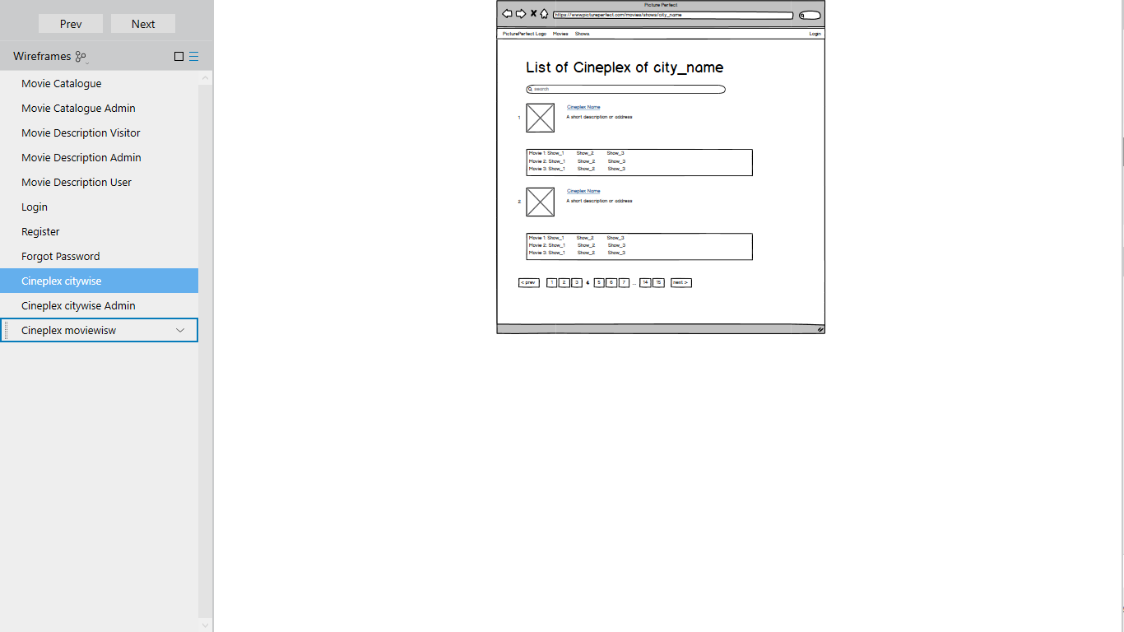

7. GET /movies/shows/{city}/{movie} - List the cineplexes screening a particular movie

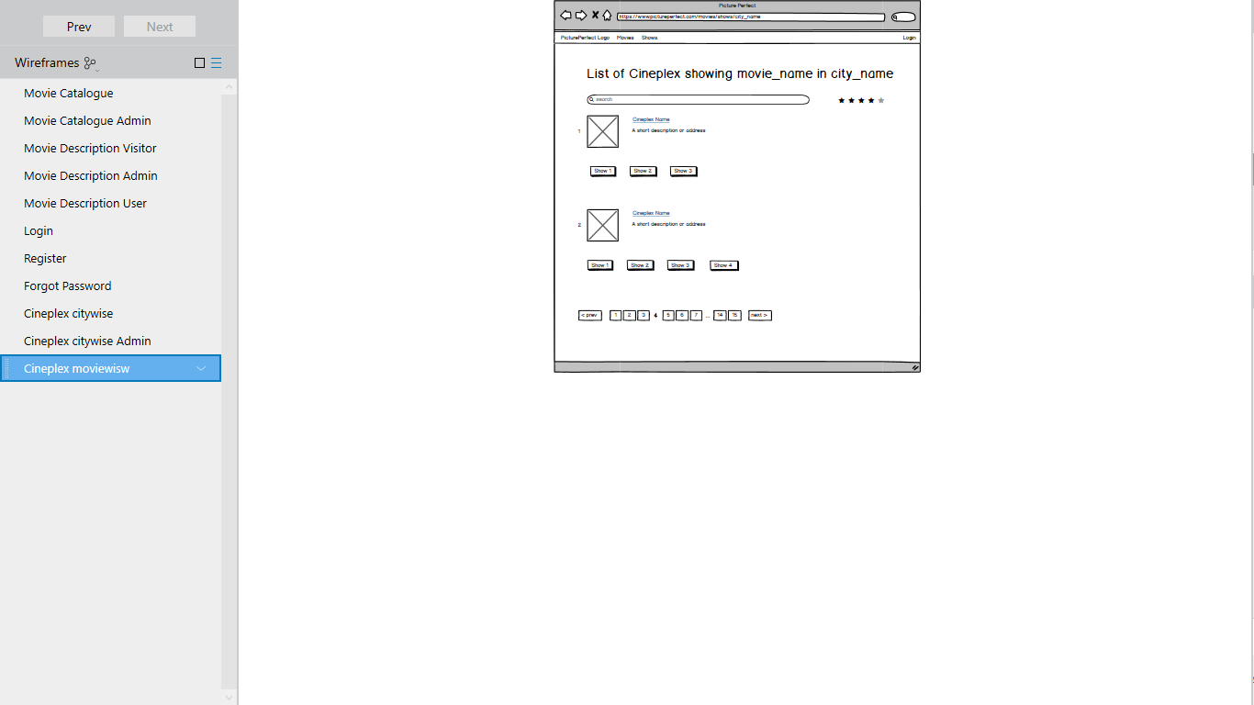

8. Get /movies/catalogue: it displays paginated list of movies, along with the associated media (links to the thumbnail pictures) for **admin** (Edit and Delete Option Enabled).

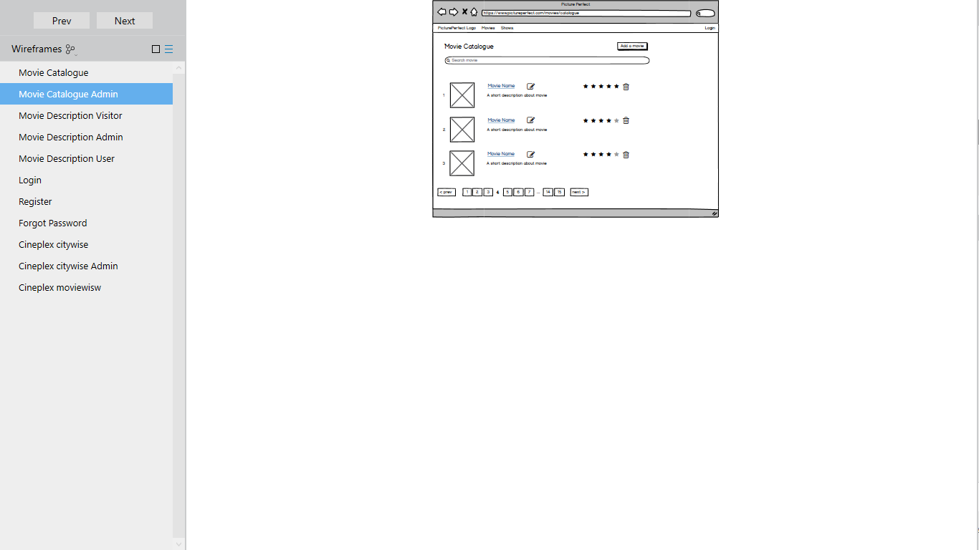

9. GET /movies/shows/{city} - List all shows in all cineplexes in a city to a **admin** (Edit and Delete enabled).

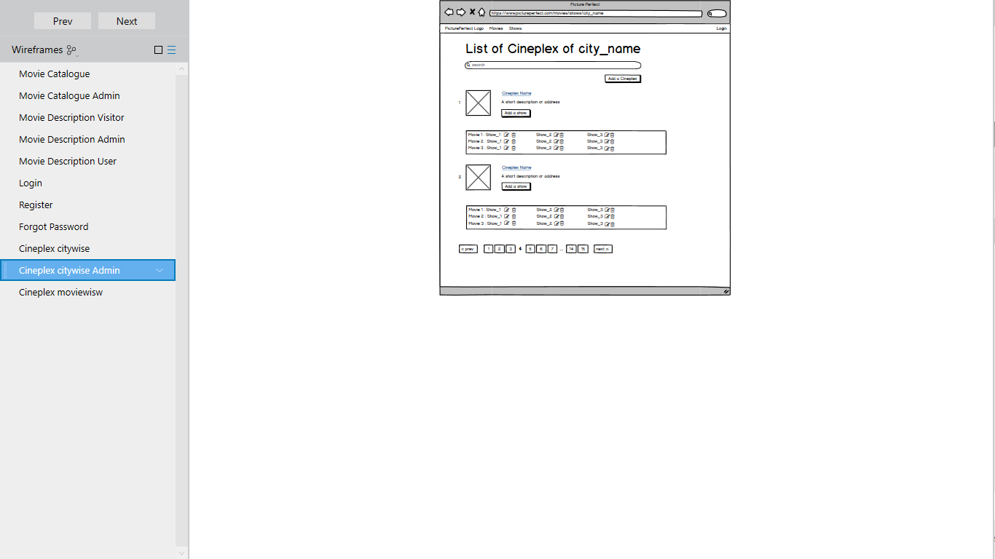

10. GET /movies/catalogue/?{name} - displays a movie/documentary by name with detailed info and the media links images, videos to the **admin** (Delete and Edit enabled).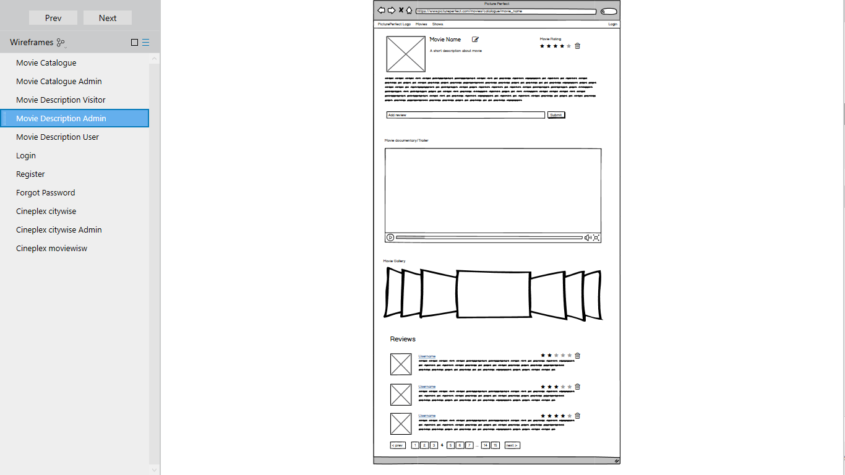

**CI/CD:** Jenkins

Jenkins is a free and open source automation server. It helps automate the parts of software development related to building, testing, and deploying, facilitating continuous integration and continuous delivery.

**Deployment:** nginx

NGINX is open source software for web serving, reverse proxying, caching, load balancing, media streaming, and more. It started out as a web server designed for maximum performance and stability.

**Code Repository:** Git

Git is a distributed version-control system for tracking changes in source code during software development. It is designed for coordinating work among programmers, but it can be used to track changes in any set of files. Its goals include speed, data integrity, and support for distributed, non-linear workflows.

**Automation:**

**Automation Tools:** selenium webdriver and pytest

Selenium WebDriver is a web framework that permits us to execute cross-browser tests. This tool is used for automating web-based application testing to verify that it performs expectedly.

**Strategies:**

* **Functionality Testing:** The main goal of functional testing is to make sure that all the functions within a web app are working smoothly without any technical glitches.
* **Web UI Testing**: Web UI testing will ensure that all the individual components within a web application are connected appropriately. We should check whether the interaction between these servers are executed properly or not with the help of the net/http/httptest testing method.
* **Compatibility Testing**: It will check our website for browser compatibility, operating system compatibility, mobile browsing and printing options. Different browsers and operating system will be used to ensure that the website will work accordingly
* **Security Testing:** This testing method is one of the most important ones for our web application as if data leaks or modifications are tolerable or not. It usually involves whether it is possible to access web directories or files directly or not and so on.